Hot Wire Setup
To ensure that the hot-wire probes give the correct response, and to avoid damage to the probe, the following step by step instructions needed to be followed.
Equipment required:
- BNC Cables
- BNC to two pin adapter
- Micro manometer
- Oscilloscope
- Constant temperature anemometer (CTA)
- Filter amplifier
- Multimeter
- Hot-wire (or XW)
- Hot-wire probe holder
- Shorting Probe
- Analogue to digital converter (or other acquisition device)

Step 1: Adjusting Overheat settings on Constant Temperature Anemometer.

N.B. When connecting Hot Wire Probe Cable to constant temperature anemometer ensure that the mode switch is set to Standby!!!
First to obtain the resistance of the cable, insert the shorting probe into probe holder. Then attach the BNC connector to the two pin adapter and insert in the Earth and Ohm sockets of Multimeter and set to 200 Ohm range. The resistance shown needs to be noted as resistance with shorting probe, and will be used later. This resistance should have a value of around 1 ohm, and it is important to check to see if moving the wires, and touching the shorting probe significantly changes this reading. If it does there is a bad connection that needs to be sorted out before plugging in the hotwire probe. Bad connections will cause calibration drift and have broken many hot wires in the past
Repeat this process with the hot-wire probe plugged in, and if using a XW then it will need to be done for each BNC cable connected to the probe holder. The resistance value with the probe connected should be around 5 ohms.
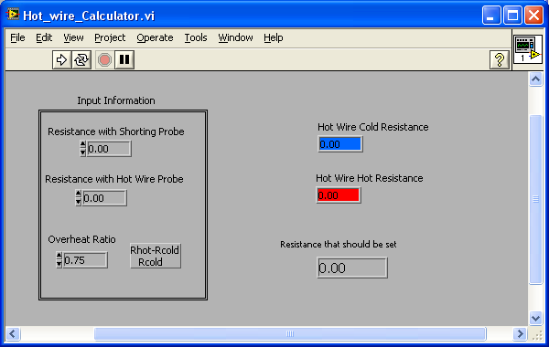

Now go to EnFlo_Hub.vi > Tools > Hot_Wire_Calculation.vi and insert values into respective, cells, as shown The overheat ratio should be 0.65
Click Run
Use “The Resistance that should be set” value to adjust overheat settings on Constant Temperature Anemometer, show in Figure 1. For example, to set a value of 7.9 Ohms, adjust the middle dial to 7 and lower dial to 0.9.
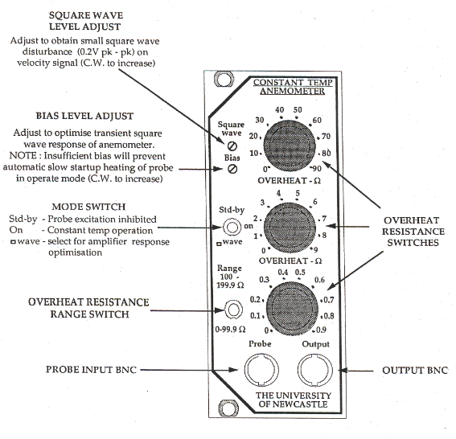
Figure 1 - Constant temperature anemometer (University of Newcastle (N.S.W.). Dept. of Mechanical Engineering 1995)
N.B. When connecting Hot Wire Probe Cable to constant temperature anemometer ensure that the mode switch is set to Standby!!!

Step 2. Plug the BNC probe cable (with the hot wire probe connected to it) into the CTA bridge making sure the mode switch is on Standby. Now set the mode switch to “on” and the output BNC from the CTA bridge should give around 1.8volts. If this is not the case you might need to adjust the Bias screw.

Step 3 - Square wave test
Now the CTA must be adjusted so that it provides the correct response. To do this connect the output of the CTA to the oscilloscope (do not use the filter amplifier at this stage). On the oscilloscope switch to ground and zero y-position, the switch back to AC. On the CTA switch to the Square wave mode.
Adjust oscilloscope settings to show square wave. Then adjust the Bias on the CTA to desired response, shown in Figure 2, with a peak to peak level of 0.1 to 0.2V.
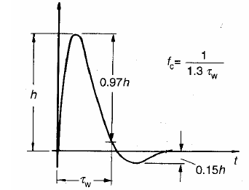
Figure 2 - Square wave response (Bruun 1995)

Step 4 - Set Offset and Gain on Filter amplifier.
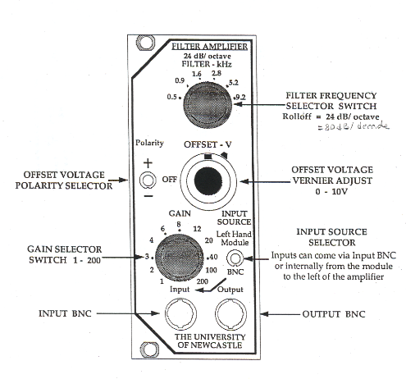

Figure 3 - Filter amplifier (University of Newcastle (N.S.W.). Dept. of Mechanical Engineering 1995)
The offset and gain then needs to be changed so that it is in the range of the data acquisition device. If using an ADC the range is typically from -10V to 10V.
Firstly connect the multimeter to the output of the CTA and set to the 20V range. Read and note down the voltage from the CTA at 0ms⁻¹ tunnel speed and then set the wind tunnel to a speed over that which is required for the testing (or the tunnels maximum speed) and take another measurement of the voltage.
Using these two values take the average which will be the offset voltage on the Filter Amplifier. Then the gain can be set by using the range from the average value of the CTA output times by a gain which fit within the ADC range. For example if the minimum CTA voltage is 2 and the maximum is 3 then the offset voltage will be 2.5V and the gain will be set to 12 as that would give a range of outputs from the Filter Amplifier to be between ±6V (±0.5V times 12); a gain of 20 wouldn’t be used as it is too close to the range of the ADC so the signal could have clipping if 10V in magnitude is exceeded.
Now move the BNC cable from CTA output to Filter Amplifier output.
On Filter Amplifier, Error: Reference source not found, set input source selector to Left Hand Module, if using unit directly to right of Constant Temperature Anemometer. The output should be from the Filter Amplifier (rather than the CTA) for the duration of the collecting data as this allows for more accurate use of the hot-wire due to increased sensitivity.

Step 5 - Calibration
Follow online help for HW Calibration at:
http://131.227.181.18/~xphayden/enflosw/beta/Manual/online/index.html

